Class 1 Newsletter

Welcome back to Term 3. I hope you all managed to have a lovely and enjoyable Christmas break. The children have loved sharing their news over the holidays and about all the wonderful presents they received. They have come back with lots of energy and positivity towards learning and are excited for our new topic ‘Amazing Animals’.

**The School Day**

We will continue to meet the children at the bottom of the ramp outside Kindergarten at 8:45. Please ensure that children are arriving promptly so that they can get straight in and settled with their morning tasks. If children are late to school can they please go straight to the office. The children will be dismissed at 3:15 from the same place they were dropped off in the morning. When dismissing, please wait for me to send your child over to you to ensure everyone gets home safely. If for some reason another adult is picking up your child this must be communicated with the teacher (preferably by email) otherwise we will be unable to dismiss your children.

**Our Week**

The children will continue to be taught by Miss Phillips throughout the week with Mrs Newns as our class teaching assistant. Mrs Brunet-Lua will continue to cover Miss Phillips’ PPA time on a Monday morning up until February half-term. When we return this will be taken over by Mrs Price who is returning from maternity leave. The children will be made aware of this change and will have the chance to meet Mrs Price before she takes over.

**PE**

We will have PE lessons with Atlas Sports on Thursday mornings, as well as on a Friday with Miss Phillips. We will also be continuing to have Forest School sessions when weather appropriate. The children also get lots of active breaks and opportunities to develop their gross motor skills through the week. The children’s PE kit needs to be worn to school on Thursday and Friday and should include; a house coloured t-shirt (green, yellow or blue), black shorts and daps/trainers. As we enter the colder months, the children may want to wear leggings/joggers and a jumper/jacket. We have recently noticed a lot of children wearing non-school uniform items of clothing, can we please ask that children are to wear school items only where possible. Please can we ensure that ALL items of clothing, footwear, water bottles and lunchboxes are clearly named to ensure items are not lost! We believe it is important that children begin to gain responsibility for their belongings; therefore it is hard for them to do so if items are unidentifiable. Please can all children come in with a coat; in case of rain or cold weather.

**Homework**

Each child in reception will have their own homework pack which will be kept in their book bags. These will contain: tricky words, number cards, sound folder and sentence builders. Homework will be checked by staff on a Friday and the folders must be present in the children’s book bag daily. At this stage children should be able to put their tricky words into sentences and should know all of the phase 2 tricky words in their pack. If your child does not please can you focus on these. The word cards are on two different colours high frequency words are in green and common exception words are on yellow, this allows the children to differentiate between them. They will also a have a pack of number cards in their homework wallets, these will be added to as the children consolidate their understanding of individual numbers. These cards are so that children can practice 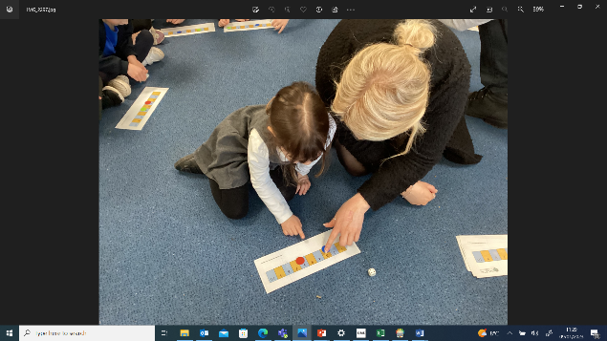recognising numbers, ordering them, writing them and representing the given number in various different ways.

**Final Note**

Please continue to engage wit tapestry and post any wow moments of your child, we love to share these with the class. It is imperative at this stage that children are reading all 4 of the books in their book bag, these must be evidenced in their reading journal. If you are finding this tricky please do let me know and we can arrange for you to come in before school to read with your child with our support.

Finally you should have all received a letter regarding out KS1 and Early Years Bedtime Stories Event which is being held at the school on Thursday 26th January. The children will get a chance to spend time in the Year 1 classroom with Miss Carter. If you do have any concerns or questions please feel free to chat to me in the playground or email me at: [lphillips@british.gloucs.sch.uk](mailto:lphillips@british.gloucs.sch.uk)

